Lab 16: Character Arrays

Lab 16a:
- Create an array to store 8 characters.
- Using a for loop, get an 8-letter word from the user, one letter at a time.
- Then use another for loop to print the complete word onto the screen one letter at a time.
- Then use a third for loop to print out the word backwards.
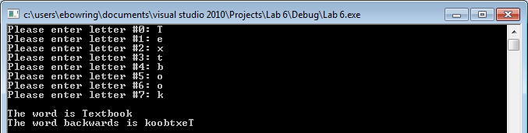

Lab 16b:
Write a function that takes your array of characters and a single character and searches through the array cell by cell for the specified character. If found, display the index at which the letter was found; if not, display a message stating that the character array does not contain that letter.
Or

Lab 16c:
Write a function that takes your array of characters and goes through letter by letter converting each character to uppercase. To convert a single letter to uppercase, whether it is already uppercase or lowercase, you can use the toupper() function:
char letter = ‘g’;
letter = toupper(letter);
cout << letter << endl; // will display G
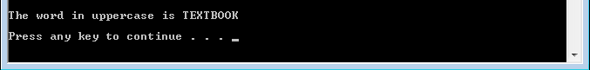

Sample output from a full run of lab code:
